EDIT 7350 - Spring 2016

An Evaluation Report of  
the University of Georgia  
Office of Online Learning’s  
**Online Fellows Program**

### 

### 

### 

### 

### Prepared by The Mega Powers

Stephen Bridges

Cheryl Despathy

Ben Hall

Chris Nylund



### 

### Table of Contents

|  |  |
| --- | --- |
| Introduction | 3 |
| Background | 3 |
| Purpose | 4 |
| Stakeholders | 4 |
| Decisions and Questions | 4 |
| Methods | 5 |
| Instrumentation | 5 |
| Limitations | 6 |
| Analysis | 7 |
| Results | 8 |
| Discussion | 20 |
| Recommendations | 22 |
| Appendices | 24 |
| References | 35 |

### 

### Introduction

This document defines the processes that will be taken to evaluate the training program provided by the Office of Online Learning (OOL) for faculty members in the University of Georgia’s Online Learning Fellows (OLF) program.

This plan has been developed by four graduate students in the Learning, Design, and Technology graduate program at the University of Georgia (UGA) in order to fulfill the requirements for the graduate course e-Learning Evaluation and Assessment (EDIT 7350). The plan has been developed in consultation with staff from OOL including Karah Hagins, Flint Buchanan, James Castle, and Keith Bailey. The four authors of this plan are Stephen Bridges, Cheryl Despathy, Ben Hall, and Chris Nylund; they are the Mega Powers.

### Background

The University of Georgia’s Office of Online Learning, established in 2012, serves as a resource to faculty who seek to teach undergraduate and graduate courses online. Oftentimes, these faculty do not have prior experience with teaching online. Unfamiliar with the tools and design pedagogy necessary to teach effectively, they may fail to produce engaging and effective learning experiences for their students. The OOL established the Online Learning Fellows program in 2013 in an effort to train UGA faculty how best to design online courses. This program has been through several iterations during the summer semesters in 2013 and 2015, including instances where the training takes place wholly online and another where training took place wholly face-to-face. While the OLF program offers some guidance in how to teach online, the primary function of the program is to train faculty in the fundamentals of online course design and associated pedagogies.

In January of 2016, the OOL launched a new OLF program. This program, with a total enrollment of sixty-one faculty broken up into nine cohorts, operated in a blended format with an online training course supported by four face-to-face meetings over the span of eight weeks. The online course is broken into 4 modules of instruction: Overview of Online Learning at UGA, Pedagogical Design in Online Courses, Creating Your Online Course, and Using Media in Online Courses. During the face-to-face meetings, cohort members meet with each other and their assigned instructional designer to discuss successes, potential pitfalls, questions, and to give feedback to one another on the creation of their individual online courses. The ultimate goal of the OLF program is for faculty to develop 25% of their course content by the completion of the program (March 2, 2016).

### Purpose

The purpose of this project is to provide our clients at UGA’s Office of Online Learning with a report outlining the efficacy and potential future viability of the newly redesigned (as of January 2016) OLF program.

### Stakeholders

The clients of this project are Keith Bailey, the director of the Office of Online Learning, as well as the office’s instructional designers: Flint Buchanan, James Castle, Karah Hagins, and Jean-Pierre Niyikora. Dan Ye, an instructional designer in UGA’s College of Agriculture and Environmental Sciences, is also helping to facilitate the OLF program. Primary stakeholders include the faculty participating in the program, the deans of the different colleges within UGA, and department heads of the respective colleges who have a vested interest in their faculty developing effective online programs. The future students of these courses are secondary stakeholders because they will be enrolled in what are (hopefully) engaging online classes.

### Decisions and Questions

The stakeholders will be looking to this evaluation to provide accurate information to support decision making on the following set of decisions:

1. Delivery options for the Online Learning Fellows will be established.

2. Modifications will be made to the Online Learning Fellows blended curriculum format to improve effectiveness and appeal.

3. Expansion options for the Online Learning Fellows will be established.

In order to make decisions informed by the best possible information, the following questions will be addressed during this formative evaluation:

1. What are the learner reactions to the program’s appeal?

2. What are the learner reactions to the program’s usability?

3. What are the learner reactions to the utility of content?

4. What corrections must be made to the e-Learning part of the program?

5. What enhancements can be made to the e-Learning part of the program?

6. To what extent are learners achieving the instructions objectives of the program?

### 

### 

### Methods

With the notion that qualitative and quantitative methodologies offer complimentary, instead of competing, approaches, a mixed method approach was used for this study (Rieber & Noah, 2008). Data sources included a quantitative survey of Online Learning Fellows (OLF) and two qualitative interviews of free form questions that provided more in-depth and robust data. Additionally, the team looked at how the faculty members’ performance scored in the Quality Matters evaluation process , i.e. determining whether they met a certain percentage of the standards (“Standards from the Quality Matters Higher Education Rubric, 5th Edition”). By triangulating multiple sources of data, the team hoped to gain a fuller picture of the overall participant experience.

The primary method of data collection was conducted via a sixteen-question Qualtrics survey that was distributed by email to all participants from the January 2016 cohort. The first portion of the survey asked users to what degree did they agree or disagree with eight statements about course organization & objectives, time demands of the course, overall effectiveness, user confidence in their learning, content delivery, and instructor responsiveness. The second portion of survey asked users to rate, using a likert scale, the quality of the interactions with their instructional designer while enrolled in the OLF program. In the final portion of the survey, users were asked three open-ended questions that they were to answer in few sentences. The questions were as follows:

1. What feature of the OLF course did you feel was **most** beneficial to you as you participated in the cohort?

2. What feature of the OLF course did you feel was **least** beneficial to you as you participated in the cohort?

3. What improvements would you suggest that would improve the OLF experience?

The secondary method of data collection was through qualitative interviews of two participants who were willing to speak with a member of the team at the conclusion event. These free-flowing conversations were conducted to gather in-depth information about the user experience of the program. The interviews provided information that could not be collected in survey form and went behind the scope of the open-ended questions included in the survey above.

### Instrumentation

To collect the quantitative survey data, the team decided to use Qualtrics, a powerful online survey tool that is available, free of charge, to UGA students, staff, and faculty. Team members simply needed to contact UGA EITS in order to gain access to a Qualtrics account. Reasons that Qualtrics was preferred over other free online survey tools, such as Google Forms or SurveyMonkey, was that the surveys have professional-looking UGA branding, the survey layouts are mobile device friendly, and the data analyzing and report generation tools are quite sophisticated. The link to the survey was distributed to OLFs at the cohort conclusion event on March 2, 2016 and via email. Qualtrics allowed the team to easily track how many surveys were begun and completed; 37 surveys were begun and 36 were completed.

### Limitations

There are many limitations to the data collected in this evaluation before questions can be answered and decisions can be made. One limitation is that the OLF participants may not have completed the 25% development of their online course and may be giving feedback at the end of the time rather than the completion of the program goal. Second, the data collection methods do not include comparing feedback to previous cohorts; the decision about methods for implementation may require additional information. Third, the learners provided estimations of hours spent engaged with the program but the survey does not authenticate this data. Fourth, the data does not account for different instructional designers assigned to the various cohorts. Therefore, there could be one instructional designer improving or detracting from the effectiveness data in a way that serves as an anomaly but it is currently impossible to separate the data to determine this. Fifth, the survey does not evaluate whether the learners volunteered to participate, or they were directed to participate. This could impact the reliability of the data for purposes of decision-making about user appeal of the program. Sixth, the ultimate goal of the OLF program, which is “to train faculty in the fundamentals of online course design and associated pedagogies," can not be fully assessed until the courses go live in the Summer of 2016. At that time, the OOL staff will conduct Quality Matters reviews of the courses to determine whether faculty translated their learning to the development of their full courses.

Lastly, the evaluation is limited by the data collection. While two interview responses can hardly be viewed as representative of the whole — generalizability is not the aim of interview collection — rather, it was valuable to learn more about the nature of a participant’s overall experience with the OLF program. The evaluation team encountered a second limitation in that the survey was not a mandatory completion item for the OLF faculty. As a result, two colleges (the College of Education and the College of Environment and Design) are not represented in the survey data. Further, since no observations of the cohorts or expert reviews were included the data is relying heavily on survey feedback and may suffer from an imbalanced triangulation of data.

### Analysis

The data collected from the survey was analyzed using the report tools in Qualtrics. These tools allowed us to visualize the data, identify trends, and draw conclusions. As for the qualitative interviews, the transcripts were analyzed for two main purposes. First, the transcripts were analyzed to identify emerging themes. Second, the transcripts were analyzed for triangulation purposes. In other words, we wanted to know if the data collected from the interviews supported the findings of the quantitative survey. We were more confident about the validity of those findings that were supported by both the survey and the interview process.

### 

### 

### Results

As noted above, survey results were gathered using the Qualtrics web application. A survey URL was distributed during the program’s Conclusion Event on March 2nd, 2016 with an email link sent out for those faculty unable to attend the event. A total of 37 faculty responded to the survey within the allocated time. This represents 61% of the total number of faculty that actually participated in this OLF program.

##### Cohort of Origin

The largest majority of faculty who responded to this survey taught in the Franklin College of Arts and Sciences (51%) with the next largest group coming from the College of Public Health (see Figure 1 below).

**Note:** Zero faculty from the College of Education or the College of Environment and Design responded to the survey.

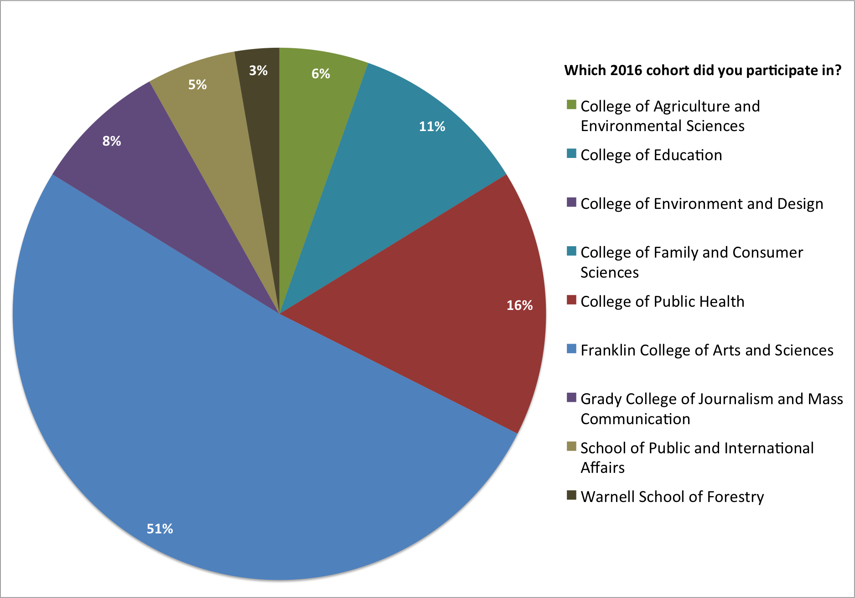

**FIGURE 1**: BREAKDOWN OF SURVEY RESPONDENTS BY COHORT OF ORIGIN

##### 

##### 

##### Experience in the OLF Program

The following 6 results data are generated from Likert-style questions where faculty were asked to state to what degree they agreed with the question. Faculty could respond Strongly Agree, Agree, Disagree, Strongly Disagree, or N/A (Not Applicable) Participants were asked several questions pertaining to their experience within the OLF program.

When asked to respond to the statement “The OLF course was well organized,” 97% of faculty responded positively (see Figure 2 below).

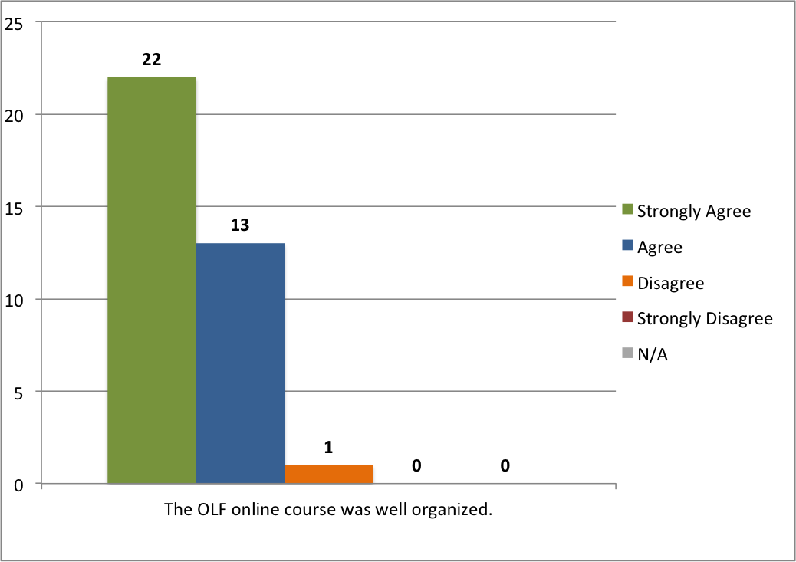

**FIGURE 2**: THE OLF ONLINE COURSE WAS WELL ORGANIZED.

The faculty were then asked to what extent they felt the OLF online course objectives were clearly explained. Again, faculty responded favorably to this prompt with 92% of faculty indicating a positive response (see Figure 3 below).

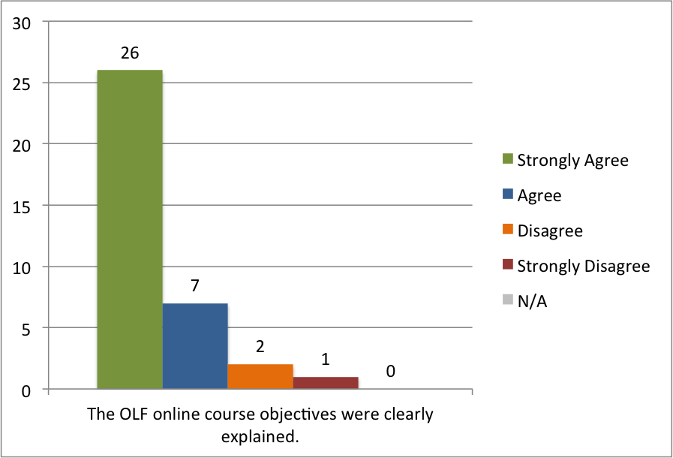

**FIGURE 3**: THE OLF ONLINE COURSE OBJECTIVES WERE CLEARLY EXPLAINED.

Similarly, 92% of faculty felt as though the online OLF course clearly articulated with the faculty’s participation expectations were (see Figure 4 below.)

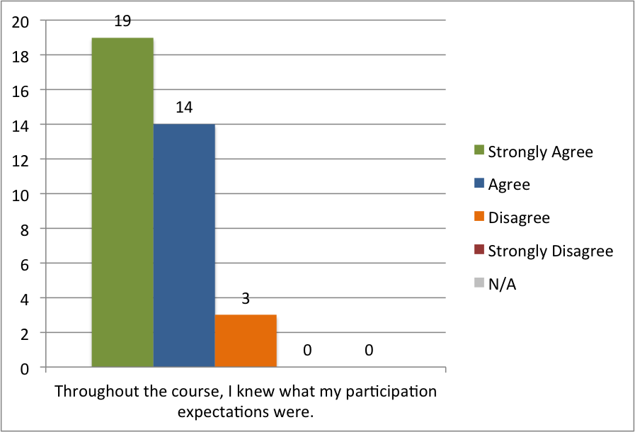

**FIGURE 4**: THROUGHOUT THE COURSE, I KNEW WHAT MY PARTICIPATION EXPECTATIONS WERE.

Faculty were then asked to reflect on the amount of time they spent working within the 4 modules in the online eLC course. They were asked to compare the estimated completion time of each module with the actual amount of time they spent in each module. Only 72% of faculty felt as though the estimated time to completion was indicative of the amount of time they really spent completing the module’s activities (see Figure 5 below).

Note: 3 faculty marked N/A to this prompt. After contacting the faculty in question, they indicated they chose N/A because they did not complete any of the activities in Module 3 of the course. This module highlighted the uses of 12 different tools within eLC. As they were creating a course using a different LMS, they did not complete any of these activities.

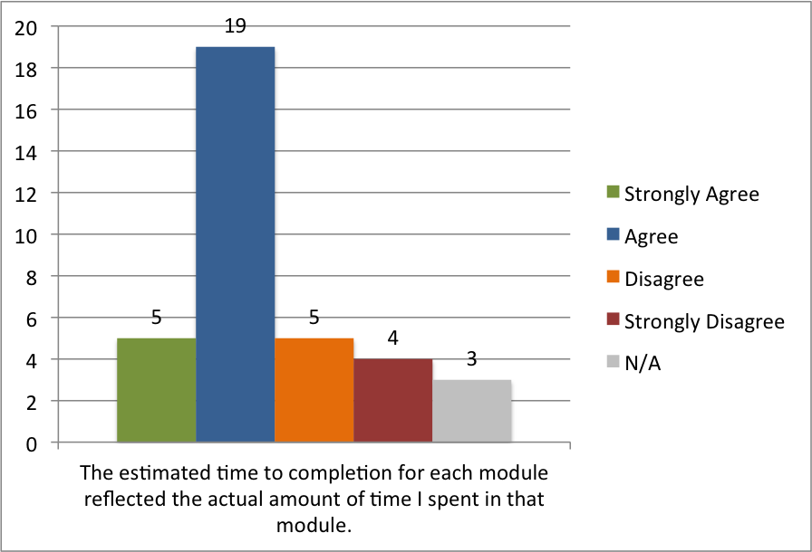

**FIGURE 5**: THE ESTIMATED TIME TO COMPLETION FOR EACH MODULE REFLECTED THE ACTUAL AMOUNT OF TIME I SPENT IN THAT MODULE

The faculty were then asked to what degree they agreed that the assignments and activities contained within the OLF course helped to prepare them in designing their own online course. 92% of faculty responded positively to this statement (see Figure 6 below).

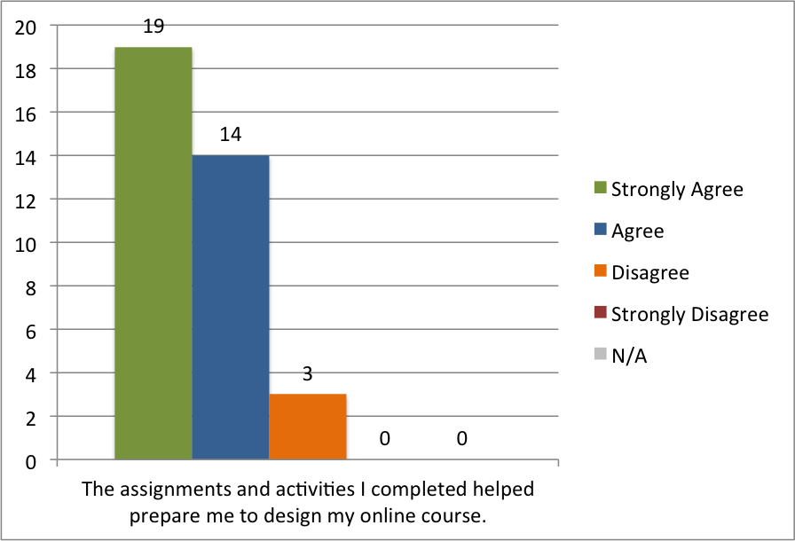

**FIGURE 6**: THE ASSIGNMENTS AND ACTIVITIES I COMPLETED HELPED PREPARE ME TO DESIGN MY ONLINE COURSE.

Faculty were then asked to assert to what degree they felt comfortable facilitating their own online course as a result of participating in the OLF program. Of the faculty who responded to the survey, 88% responded positively (see Figure 7 below.)

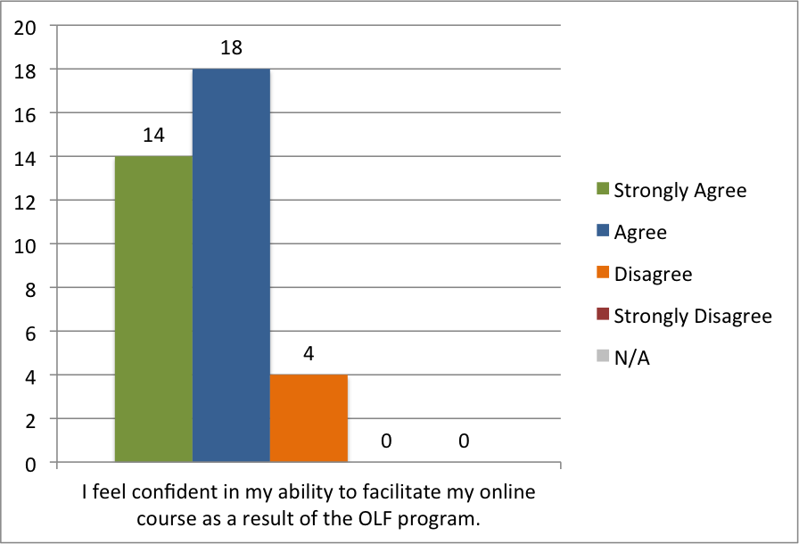

**FIGURE 7**: I FEEL CONFIDENT IN MY ABILITY TO FACILITATE MY ONLINE COURSE AS A RESULT OF THE OLF PROGRAM.

##### Instructional Designer Feedback

As a part of their experience in the OLF program, each faculty operated within a cohort of their peers led by an instructional designer. The following survey questions addressed how faculty felt regarding their interactions with their assigned instructional designers.

At the beginning of the OLF program, each instructional designer communicated what his or her level of responsiveness would be to the cohort members. 97% of the faculty respondents indicated that they felt as though the responsiveness of the instructional designer matched what was stated at the outset of the program (see Figure 8 below).

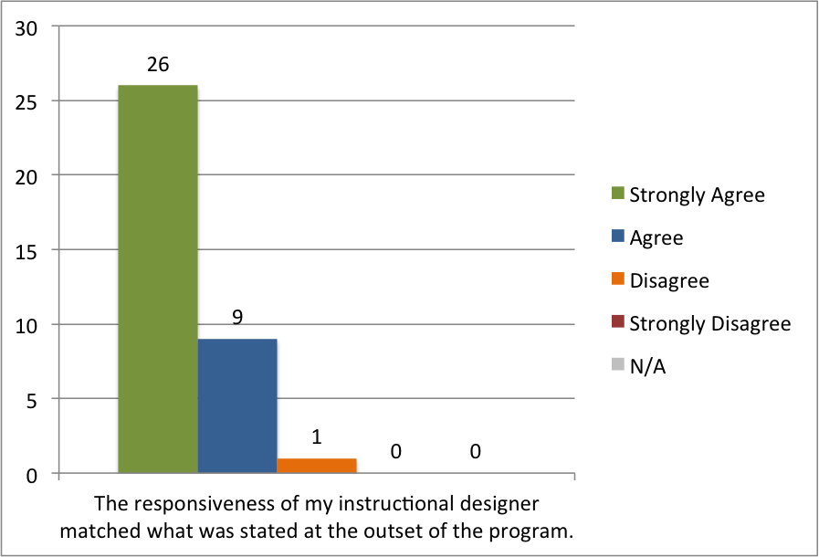

**FIGURE 8**: THE RESPONSIVENESS OF MY INSTRUCTIONAL DESIGNER MATCHED WHAT WAS STATED AT THE OUTSET OF THE PROGRAM.

The faculty were then asked to rate the quality of their experience with their instructional designer. Faculty were asked to what degree they agreed with 3 statements and had to choose between ‘Excellent,’ ‘Good,’ ‘Average,’ and ‘Poor. For the following 3 statements (see Figure 9 below), over 92% responded favorably.

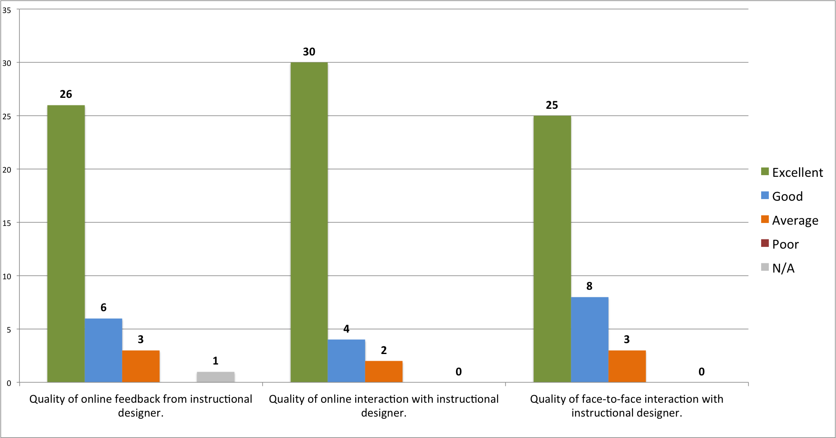

**FIGURE 9**: QUALITY OF EXPERIENCE WITH INSTRUCTIONAL DESIGNER.

When asked how much time they spent each week in the OLF online course, 56% of respondents indicated they dedicated 2 to 4 hours to the course, with 41% claiming they spent more than 5 hours a week in the course (see Figure 10).

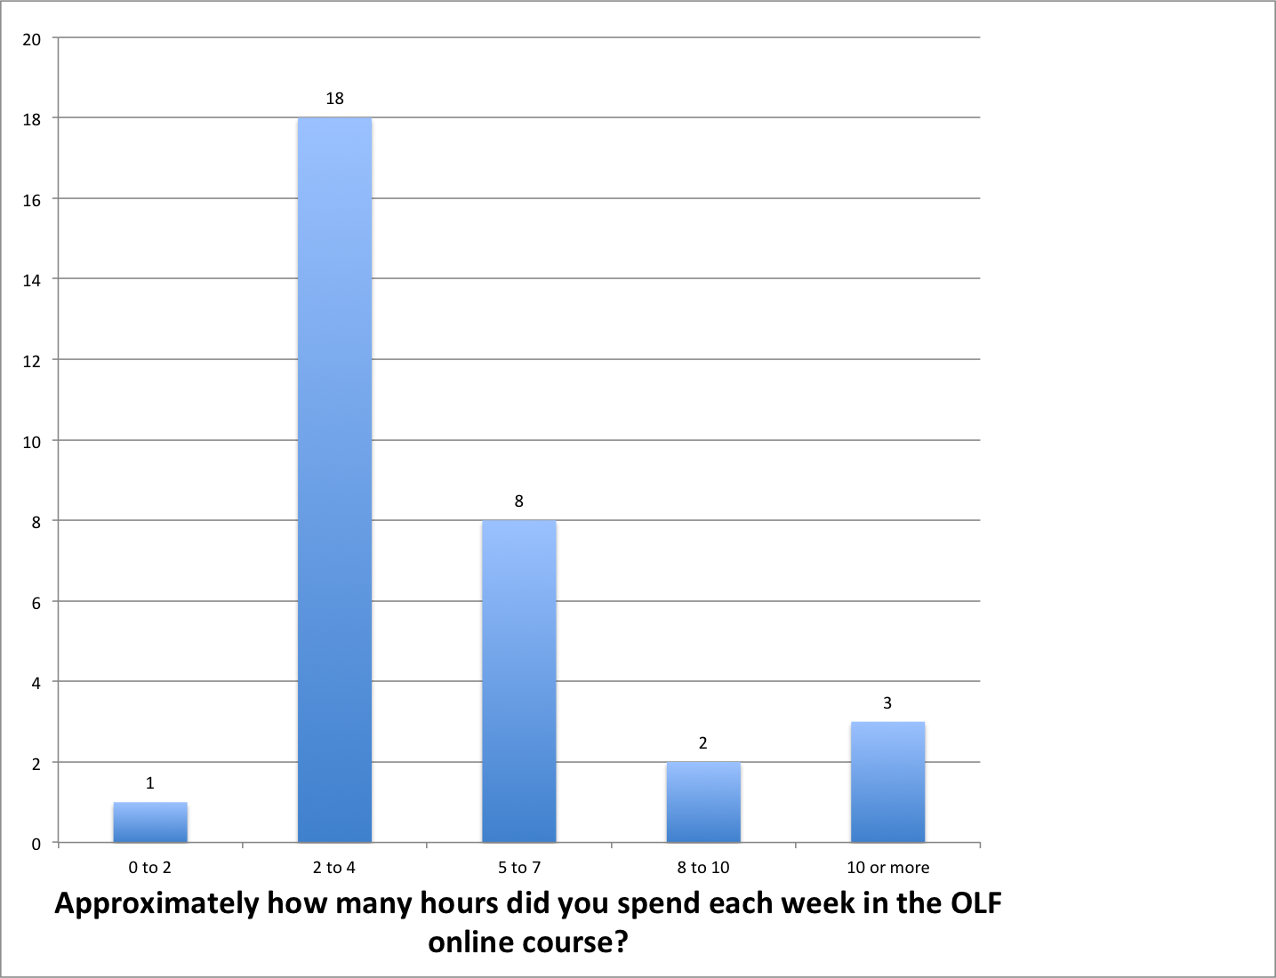

**FIGURE 10**: APPROXIMATELY HOW MANY HOURS DID YOU SPEND EACH WEEK IN THE OLF ONLINE COURSE?

##### Likes, Dislikes, and Suggestions

The survey ended with three open ended questions. While we will not dive deep into every respondent’s answers to this prompt, we will be addressing certain themes that occur.

1. What feature of the OLF course did you feel was **most** beneficial to you as you participated in the cohort?

By far, the faculty seemed to respond strongest to the face-to-face component of the OLF program. They found value in being able to brainstorm with their peers and instructional designer on questions or issues they encountered in the course design process. These meetings also allowed the cohort members to see how their peers were designing and developing their own courses, which then gave ideas to the rest of the group.

Participants also repeatedly stated that going through an online course as “students” gave them a new perspective to consider when designing their courses. For example, one faculty wrote “It was extremely helpful to utilize all of the eLC features from the student perspective… which is helping me to design as an instructor.”

1. What feature of the OLF course did you feel was **least** beneficial to you as you participated in the cohort?

The responses to this question echoed the results gathered from the earlier data about how much time faculty spent engaging with the OLF program. Faculty indicated that some of the earlier modules contained too much content, as one faculty stated “A bit too much content made some of the introductory modules burdensome and overwhelming. QM (Quality Matters) should be discussed later in the program and as its own separate session.”

Additionally, some of the faculty felt that the self-assessment quizzes detracted from the experience and added to the length.

1. What improvements would you suggest that would improve the OLF experience?

The main theme to draw from the responses to this question indicate a desire for more face-to-face interaction and a longer program timeline. Several faculty also requested a greater database of resources to draw from in terms of templates, course designs, layouts, or available widgets.

##### Focus Group Results

A number of interesting themes emerged from conducting a focus group interview with two OLF participants at the OLF conclusion event in March. Both participants strongly agreed that the OLF program was beneficial overall and was a worthwhile experience for faculty preparing to teach online for the first time. These participants suggested that the program could be longer in order to cover more in-depth material such as pedagogy and to give participants more time to create their own online courses. This latter comment echoes a criticism of the course that was expressed in the survey, i.e., that the actual time it took to complete coursework was significantly longer than the anticipated time.

When asked about other frustrations with the course, the participants discussed the “unfriendly” interface of eLC. One participant discussed how navigating within eLC was needlessly difficult at times and that, from an instructor’s perspective, organizing one’s content was unintuitive. Additionally, an interviewee expressed anxiety over whether eLC would remain the long-term learning management system for the university. She wanted to know what would happen to her course, should UGA decide to switch platforms, and who would be responsible for making sure that her course would still function properly.

### 

### 

### Discussion

The overarching goal of this report is to evaluate the training program provided by the Office of Online Learning for faculty members in the University of Georgia’s Online Learning Fellows program. More than half of the faculty that participated in this OLF cohort responded to our 16 question survey (Table 1), providing us with a relatively sufficient sample size to work with. Of the faculty respondents, a majority of these respondents came from the Franklin College of Arts and Science, while we received zero responses from the faculty members in the cohort from the College of Education and the College of Environment. While these factors undoubtedly skewed the results, we found that there was still plenty of useful data. Despite this acknowledged shortcoming with the data set, the evaluation team was able to learn not only what was working and what was not, but was able to identify some of the strengths and weaknesses of the OLF course. Additionally, the stated primary function of the program, “to train faculty in the fundamentals of online course design and associated pedagogies," will not be known until the courses that were designed by this OLF cohort go live, which will not happen until June 2016.

Based on the survey responses, participants had an overall positive experience with the OLF program, as noted in Figure 8. This notion was echoed with over 90% satisfaction in all of the following categories: the organization of the module, statement of the course objectives, and clear expectations.

##### Online Course

The eLC learning management system came up in both the qualitative and quantitative responses, ranging from frustration with its usability to the concern that their content would not transfer to a new eLC or LMS should that need ever present itself.

While the majority of respondents were satisfied with the modules, many of them noted that they needed and wanted more time to work on the program with several interview results mentioning the fact that they would like more time to explore the concepts of the course in more depth. One faculty member noted “A better idea of how much time consuming the course is, before starting the workshop (and not at the first meeting).” This comment was echoed in both the qualitative and quantitative responses.

Some of the faculty complaints with the course and the setup of the OLF cohort were issues outside of the OOL’s control. For example, one faculty member mentioned the stress of the additional responsibility of participating in the OLF cohort (and accompanying course) while juggling other responsibilities: “I was also intimidated by the 25% expectation for course prep, but that was largely because I am prepping an entirely new course and had a large grant proposal that I was invited to prepare shortly after the course started and was due for submission just after the course finished.”

##### Face-to-Face

The face to face meeting portions of the OLF course received some attention from our respondents as well, specifically in the open-ended questions. Several respondents found the one-on-one meetings with the instructional designer to be very helpful, with one faculty member noting that he/she had used the eLc for eight years but the individual attention helped remove many of the “roadblocks to building a course.” Furthermore, several faculty members mentioned that they would like more time for hands-on lab practice and face-to-face meetings, which adds weight to the strengths of the face-to-face interactions.

While the feedback regarding the face-to-face meetings were positive overall, a few respondents noted that while the one-on-one meeting were helpful, the group meetings were not always as effective for various reasons. In these small group settings, there were instances where every faculty member had not reached the same point in the course, the agenda was not always clear for these meetings, and the recurring sentiment that there was not enough time, specifically for hands-on and small group meetings.

### 

### 

### Recommendations

The project team compiled recommendations based on the evaluation feedback into two categories: program format/support and technical issues.

##### Program Format/Support

**(1) Timeframe**

The program participants struggled to complete the required tasks in the estimated time each task was provided. The program should extend to 10-12 weeks and incorporate univeristy breaks as breaks from the cohort work. Participants felt that university breaks are often a time spent catching up on work for their regular job duties, much less the additional work from the cohort curriculum. Participants could be offered a second program that focuses on advanced design and pedagogies of online teaching.

**(2) Differentiation**

Some participants who are possibly more advanced or more comfortable with online development requested the option to be segregated into an advanced cohort. By grouping like-level participants together some small groups may be able to have more than the base-level 25% development goal completed. One possibility is to begin with a diagnostic or basics opt out quick to move into a more advanced small group.

**(3) Meetings**

Participants reacted favorably to the program including both asynchronous online work and face-to-face meetings. However, the large group meeting at the end received some unfavorable feedback; these participants did not specify to the nature of their opinion, so it is not recommended to make any changes to the large group meeting at the end. Small group meetings with the instructional designers might benefit from having a meeting agenda sent to its participants prior to the meetings. These agendas would better help participants prepare for the conversations at small group. Some participants gave feedback that more individual sessions with the instructional designer could be beneficial. These individual sessions would allow the instructional designers to give directed feedback to an individual participant about her/his course design and development. These individual sessions could even be virtual to help participants practice using the virtual office hours feature in the eLC.

**(4) Accountability**

The participants would benefit from increased accountability to complete the OLF coursework. One option is to add a points or grading system with a required number of points or a required grade in order to pass the fellows program. Administrators need to be more consistent in requiring participants to use their eLC courses that are developed in the program. However, it is recommended that the instructional designers begin with setting required deadlines of module completion tasks before the small group meetings. This would help participants be more aligned to the timeline for the coursework.

##### Technical Issues

**(1) Announcements**

Many announcements were sent to participants during the program. However, some were sent via email and some were posted in the eLC. It would be best if the announcements were streamlined into all email or all eLC, but not both. This would encourage improved executive functioning of participants, and therefore, a bigger chance of participant success.

**(2) eLC Options**

Participants asked for more options for personalization and customization of the eLC course design. One option could be to include templates for participants to use for course design. A second option could be to give participants access to peer courses to get inspiration and ideas for their own course design.

**(3) Metadata**

In order to better align the estimated time for tasks with the actual time it takes to complete required tasks the eLC could utilize metadata records to track current and/or past participants. This metadata could help resolve why it takes 8-12 hours per week for some participants, but an overall average of 2-4 hours per week of work.

### Appendices

##### Appendix A - *Instrument #1: OLF Survey*

|  |  |  |
| --- | --- | --- |
|  | **Statement or Question** | **Question Type** |
| 1. | Which 2016 cohort did you participate in? | Open |
| 2. | The OLF online course was well organized. | Likert |
| 3. | The OLF online course objectives were clearly explained. | Likert |
| 4. | Throughout the course, I knew what my participation expectations were. | Likert |
| 5. | The estimated time to completion for each module reflected the actual amount of time I spent in that module. | Likert |
| 6. | The assignments and activities I completed helped prepare me to design my online course. | Likert |
| 7. | The information presented in the OLF online course helped prepare me to design my online course. | Likert |
| 8. | I feel confident in my ability to facilitate my online course as a result of the OLF program. | Likert |
| 9. | The responsiveness of my instructional designer matched what was stated at the outset of the program. | Likert |
| 10. | Quality of online feedback from instructional designer. | Likert |
| 11. | Quality of online interaction with instructional designer. | Likert |
| 12. | Quality of face-to-face interaction with instructional designer. | Likert |
| 13. | Approximately how many hours did you spend each week in the OLF online course? | Open |
| 14. | What feature of the OLF course did you feel was **most** beneficial to you as you participated in the cohort? | Open |
| 15. | What feature of the OLF course did you feel was **least** beneficial to you as you participated in the cohort? | Open |
| 16. | What improvements would you suggest that would improve the OLF experience? | Open |

##### 

##### Appendix B - *Responses to Likert Questions*

##### Likert-All Data.png



##### 

##### Appendix C - *Responses to Open Ended Questions*

1. What feature of the OLF course did you feel was **most** beneficial to you as you participated in the cohort?

|  |
| --- |
| 1. - hands on possibilities - support from instructional designer |
| 1. all of the material was new to me and most of it I will incorporate in my online class. I wish there was more material in how to make a screen-o-metic video and even how to upload videos for my online course. Most of my learning happened with my interaction with Flint and Steven, which was incredible. |
| 1. All of the videos that demonstrated how to create components of the online course |
| 1. all the materials in the courses we got enrolled in on eLC |
| 1. Asking me to start creating 2 modules of my own course. It was an excellent way to practice, using the new tools I've learnt in the course. |
| 1. Content development using template |
| 1. Examples often helped but it would be good to prepare us with basic use of elc and blackboard. |
| 1. Example videos/presentations that walked us through different features of ELC - "how to" videos. Also, the master course and the available templates were extraordinarily helpful. |
| 1. Face-to-face meetings with cohort |
| 1. Face to face time and the smaller group meetings |
| 1. Focus on structuring learning objectives |
| 1. Group discussions |
| 1. Group interaction and face time with instructor |
| 1. It was extremely helpful to utilize all of the eLC features from the student perspective. We had to submit to a drop box, post and reply in discussions, take quizzes and self assessments, and complete modules. All of that helped me to understand eLC from a student perspective, which is helping me to design as an instructor. |
| 1. Made you think about how a student learning online would learn differently than a student who is in class listening to your lecture. |
| 1. Master Course |
| 1. Meeting D where we saw how members of our cohorts had implemented their learning, as it provided ideas for how we can organize our own modules/assigments. |
| 1. Module 3 |
| 1. Module 3, pedagogical design in online courses. |
| 1. one-on-one meetings with the instructional designer |
| 1. Practically every feature |
| 1. Quality matters and self-assessment |
| 1. Repository of info I might need later |
| 1. Seeing the OLF course online helped me to think about how to organize the information in my course (so having a model). |
| 1. The 2 modules that were step by step guides for the development of the course. And the presence of my e-course in ELC for me to actually develop it in real time. |
| 1. The ability to go back and take certain modules again. |
| 1. The actual OLF course was a great example to go by as were the other courses. |
| 1. The brief face to face check ins that we had. |
| 1. the course design literature |
| 1. the design document section and units on UGA policies and media/Kaltura |
| 1. The fact that it is structured as an actual course, using the tools we'll use in our course, really helps illustrate and instruct through hands-on activity. i.e. what we should be doing in our courses! |
| 1. The modules going through the different tools and sets of information needed to both set up and teach online classes. |
| 1. The modules that outlined pedagogical approaches to online learning were most helpful. |
| 1. The role of Stephen as a sounding board for design as well as IT expert was really helpful in moving me past any of the roadblocks to building a course. Further, the resources in Module 3 were so helpful. I have used eLC for eight years and had to find each of these resources on my own. |
| 1. The suggestions for overall structure of the course and the general comments regarding similarities and differences between OL and F2F courses. |
| 1. Working through the modules & seeing what the students will be doing. Gave me a better understanding of how to structure my course. |

1. What feature of the OLF course did you feel was **least** beneficial to you as you participated in the cohort?

|  |
| --- |
| 1. Constrained timeline |
| 1. To me all is fine but required lot of time |
| 1. It was nice to have a well-structured introduction to using eLC that I could go through at my own pace. |
| 1. Remedial use of Elc (taught online for 4 yes) |
| 1. Amount of hands on interaction. |
| 1. Since I wasn't planning to use eLC, I didn't complete that module. So it wasn't beneficial to me, but I'm sure it was for others. |
| 1. Quizzes |
| 1. This is nitpicky, but I would prefer the examples to come from the ELC version/setup that we are using rather than linking to separate university pages. It would help clarify the finer points and save some time. |
| 1. All the eLC tools. The links out to other resources were a bit tedious. I got lost in terms of finding my way back. |
| 1. There is a lot of jargon involved in using eLC and teaching online courses, and it's difficult to keep track of what is being referred to in all the emails and course itself. |
| 1. A bit too much content made some of the introductory modules burdensome and overwhelming. QM should be discussed later in the program and as its own separate session. |
| 1. Can't think of anything I would indicate here. |
| 1. AT meetings B and C, we in the cohort (not our designer, who was well-prepared) weren't at the same places in our preparation, meaning that it was difficult to get a discussion going. The hands-on approach has been the most beneficial. |
| 1. I did not spend too much time on my own looking at the example courses. I like that they are available, but I looked at them more during our cohort meetings than I did on my own time. |
| 1. Having us take an course in order to proceed. Although I understand the intention to take us thru the online approach to a course, it came as a surprise to me that I would have to take a course rather than be instructed in how to work systematically thru the process ourselves. I would rather have been introduced to the various possibilities of preparing an online course than actually doing a course. |
| 1. N/a |
| 1. some of the quizzes seemed a bit much |
| 1. videos and pet pictures; discussion board (blind leading the blind: how can we engage in peer-education when many or most of us don't know anything?) |
| 1. The small group meetings were not extremely useful. We were asked to share our problems but most of us had very specific problems, related to a specific course. Most of the time, I was not even able to understand the issues. |
| 1. I felt the in-person meetings were disjointed and not well organized. This is most likely a function of our group being all over the place in regards to planning/effort/commitment. But given our dysfunction, some structure may have helped. |
| 1. NA |
| 1. the face-to-face meetings didn't add too much. especially the large group ones. the small group ones were better. |
| 1. Because the online and one-on-one course times were so efficient, the large group face-to-face time felt less so. That said, this is one of the more professional offices I have seen at UGA and the time spent in the large-group settings was still really useful. |
| 1. NA |
| 1. The large group meetings |
| 1. sometimes there was too much supplementary information in the modules |
| 1. Wrap up meeting length |
| 1. The small cohort meetings. |
| 1. n/a |
| 1. n/a |

1. What improvements would you suggest that would improve the OLF experience?

|  |
| --- |
| 1. Rework the timeline |
| 1. Extend to 10 weeks |
| 1. Please have all instructions and calendars available via the OLF course on eLC. If I received something on paper or via email, I found it harder to keep track of. |
| 1. More models of what instructors can do in an online course (widgets, podcasts, types of assignments, teaching strategies, etc.). |
| 1. It would be nice to have some organized work session where we are face to face working on our courses. It would be nice to work through the tutorials in lab with instructor when we can ask real time questions. |
| 1. More flexbile timeframe for complete, incorporating semester breaks. |
| 1. More hands-on lab practice |
| 1. More group face to face meetings |
| 1. Slightly better feedback as to what we "should" be seeing: for whatever reason, I did not have access to the OLF course at the start but did not realize it until into February, putting me pretty far behind in course development. |
| 1. Increased individual session(s) with the instructional designer |
| 1. See above. |
| 1. Show us, in the opening meeting, examples of courses already created. Will help to visualize our own courses. |
| 1. Send out meeting agendas ahead of time for cohort meetings so we can come prepared. |
| 1. Start with the basics and hand hold us thru the process every week. |
| 1. More options for personalizing your course |
| 1. I don't have anything |
| 1. Spread the content out more evenly over the semester. More f2f small-group meetings with instructional designer dedicated to single-topics e.g. discussion board, gradebook, writing quizzes. MANY MORE RESOURCES, financial and instructional, devoted to accessibility. You can't just leave us alone with this. It is not "our problem" to fix; it's the university's. And there are some assignments that CAN'T be designed "universally" without additional help. |
| 1. A better idea of how much time consuming the course is, before starting the workshop (and not at the first meeting). Maybe a few individual meetings... online to practice our virtual office hours? |
| 1. I would suggest more short-term, smaller-chunked deadlines. |
| 1. More one on one. But I know that is really difficult. Also I loved the last meeting seeing what everyone did. It gave me fantastic ideas for my course. Maybe more sharing with others from the cohort or previous cohorts. |
| 1. This may have been the nature of my school's communication about the course, but I was completely unaware of the time commitment needed for the OLF program. That said, once I began to commit time, I realized that it was going to make my online courses AS WELL AS my face to face course much, much better. If there is not a clear communication about the time commitment (there very well may have been) from your end, I think it would be really helpful to let professors know before they commit to the program. |
| 1. I am satisfied with contents so far |
| 1. I think more group meetings would be good (or online discussion among participants) because I found myself learning a lot during those. Not just OL courses, but pedagogy in general. If offered/constructed as on-line discussion, I think it might serve as a better demonstration tool of how a discussion should work also |
| 1. More time for the smaller cohort meetings. I learned a lot from my peers, but there never seemed to be enough time. It would have been nice to see more of my colleague's courses and have more sharing time. |
| 1. Extending the time a couple weeks. Will fully admit that I did not meet every goal set out (the 25% done by end of the training). It only lasts a little over a month (End of January to beginning of March) and that is a short time frame to do the training which takes a lot of time itself and develop 25% of the class while continuing my regularly scheduled classes, research and extension duties. I understand that this is on me to have been more diligent to get everything done faster, but for a lot of us who have never taught online, it took a few weeks just to digest how different it was from the in classroom teaching we do. My suggestions would be to make the final meeting the week after spring break. Spring break is a time a lot of us play "catch-up" since it is light on meetings and we have more time to just block of to get work done and this would be excellent to ensure more of the fellows got through all of the goals. |
| 1. Online course templates would have been a better place to start. Courses are so different. What works for a writing intensive course is not going to work for a lecture-based course, or a survey course v. an upper level course. |
| 1. If there could be more face to face accountability I would have been more likely to reach the goals. |
| 1. more opportunities for hands-on |

##### 

##### 

##### Appendix D - *Focus Group Interview Transcript*

**Interviewer:** Tell me about your experience in the Online Fellows Program.

**Interviewee 1:** I liked having our small groups. That was really helpful because we generally all taught the same general message and so having our little groups meet a lot was really helpful. I would have liked to have more of that. I felt that the time we had was never enough. It was a good thing but I would have liked to have more of that.

**Interviewee 2:** With the expectation that we fill our course for summer, I feel like this program could have started in October. [inaudible] But I did really like the small cohort meetings—so meaningful, so productive. I learned so much and I was able to take things back and just immediately apply to what I was working on.

**Interviewer:** So when you’re talking about the small cohort, are you talking about the face to face meetings or are you talking about online interactions?

**Interviewee 2:** The face to face meetings. [inaudible]

**Interviewee 1:** If you’re thinking about expanding, it was very helpful for everyone to have their laptops with them because if there was a problem, then someone could show me what they were doing or how to fix it right there. Like we were talking about earlier, you could show someone how to include an RSS feed by clicking a button here, etc.

**Interviewee 2:** I think you could offer some more workshops, spread out throughout the semester, especially eLC topics, or how to use Kaltura, or how to use Camtasia, or how to use whatever, that would be really really helpful. I go to so many training and development courses it’s ridiculous. [So] having more options spread throughout the semester, I think would really help us with these online courses. And some that even require homework, you know. If you’re gonna do a session on Kaltura, having faculty bring something that they’re working on in, that would be really meaningful. I think for me, having hands-on development, for me is a lot more meaningful than going back and talking about it days later.

*[At about the five minute mark in the conversation, the audio recording unfortunately cut out, so the remainder of the transcript is from notes.]*

**Interviewer:** Can you tell me about some of your frustrations with the course?

**Interviewee 1:** eLC is not the most user-friendly website. There were often times when I would be looking for information, either as a student or as instructor, where I would press the back button and it would take me to place that I was not expecting. I also was frustrated at times with the layout of my content when building my course for summer semester.

**Interviewer 2:** I am also concerned about what would happen to my course should The University of Georgia decide to switch their elearning content management system to a different service provider. For example, what would happen to my course if we decided to move away from eLC (meaning: Desire2Learn)? Would my courses still work? Who would be responsible for making the switch and how would we handle it?

##### 

##### 

### References

Rieber, L. P., & Noah, D. (2008). Games, simulations, and visual metaphors in   
 education: antagonism between enjoyment and learning. *Educational Media   
 International*, *45*(2), 77-92.

“Standards from the Quality Matters Higher Education Rubric, 5th Edition.” Quality

Matters. Retrieved from   
 <https://www.qualitymatters.org/node/2305/download/QM%20S>

tandards%20with%20Point%20Values%20Fifth%20Edition.pdf